# Creating a Story Map & Embedding Elsewhere

storymaps.arcgis.com

#### [ArcGIS StoryMaps](https://storymaps.arcgis.com/)

23 Steps

Go to <https://storymaps.arcgis.com/>

1- Click on 'Sign in to ArcGIS StoryMaps'

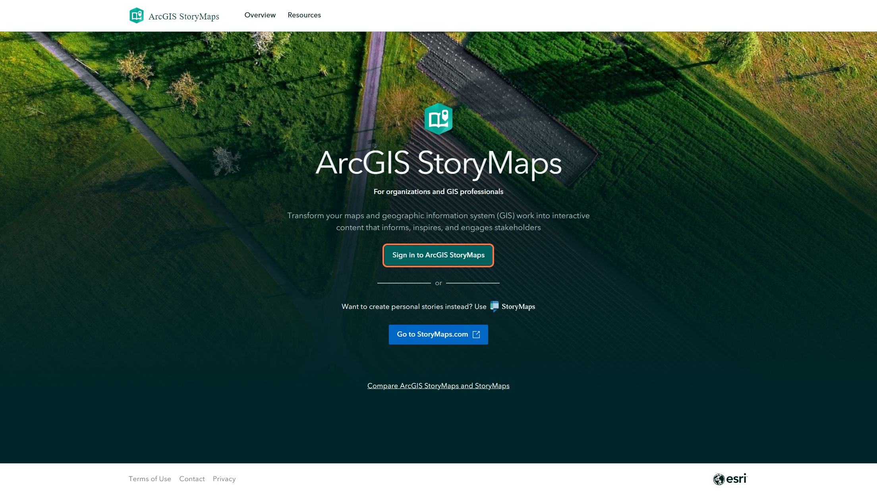

2- Click on 'Your ArcGIS organization's URL

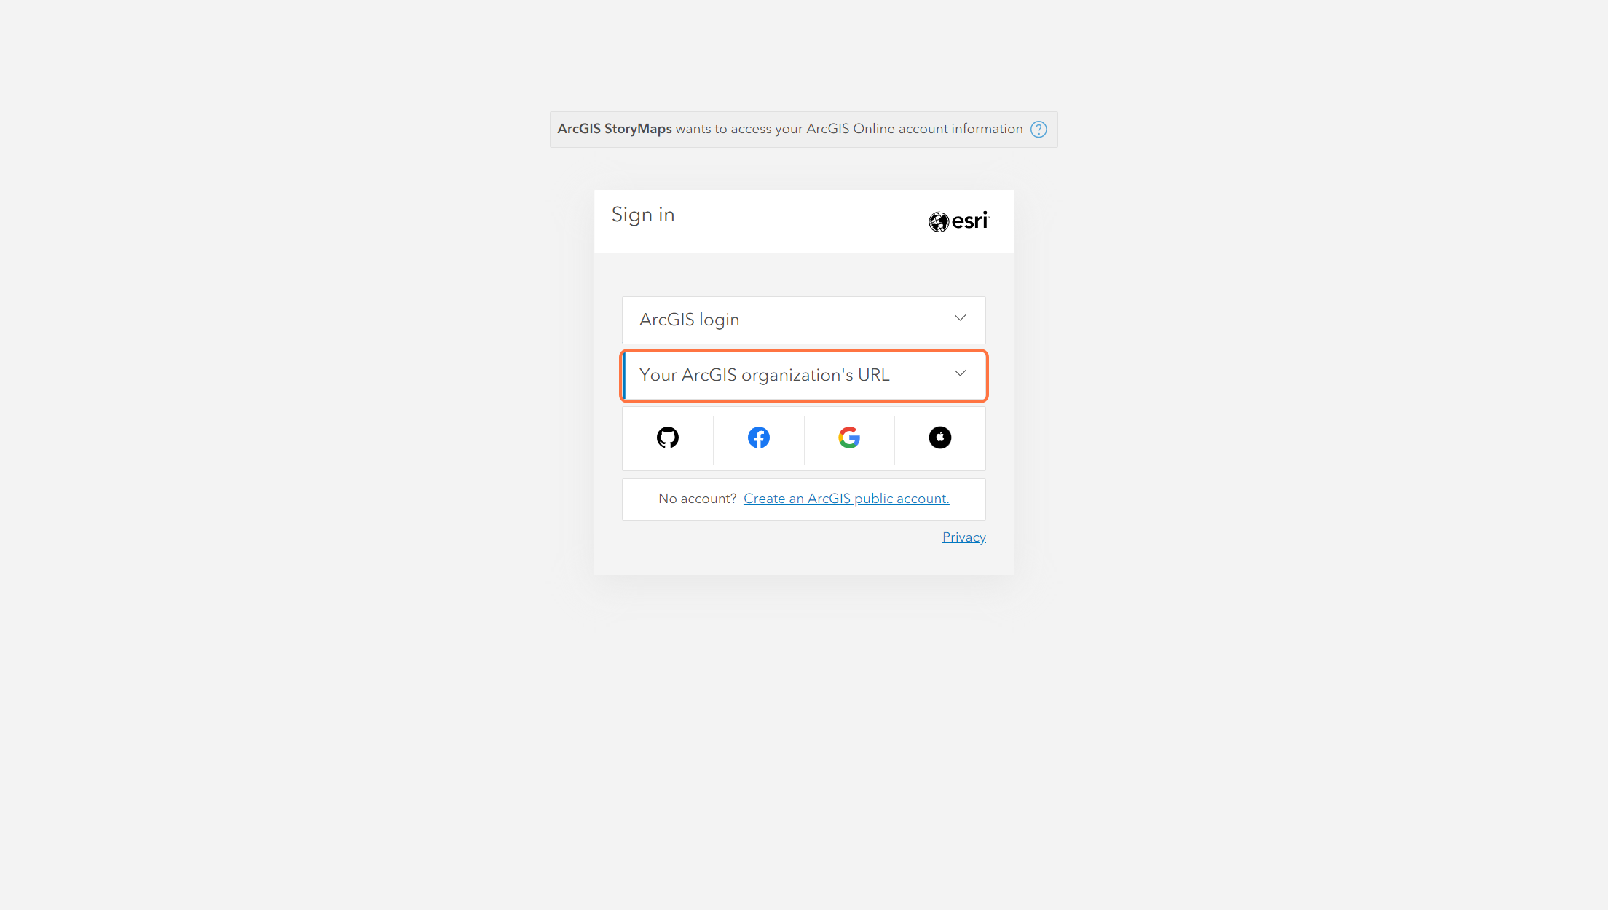

3 - Type "compassinfo"

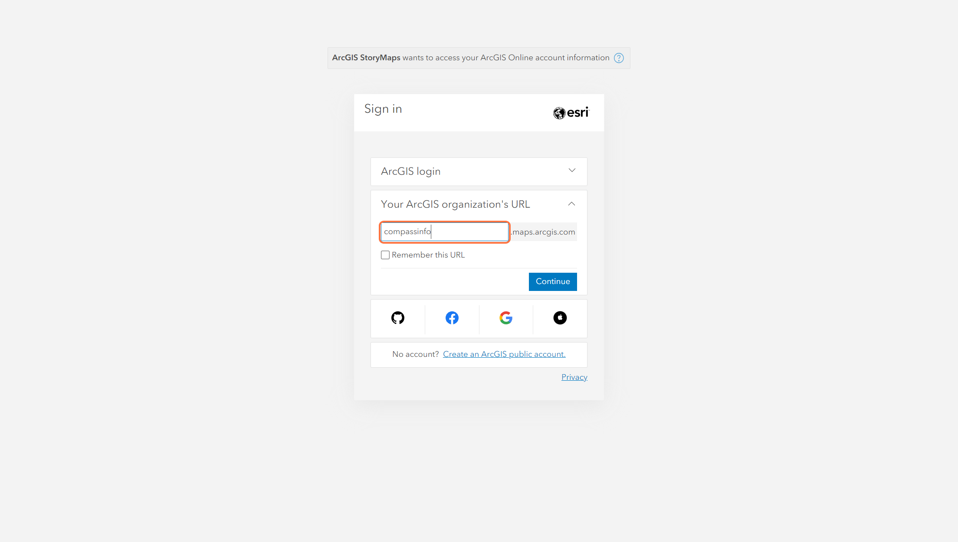

4 - Click on Continue

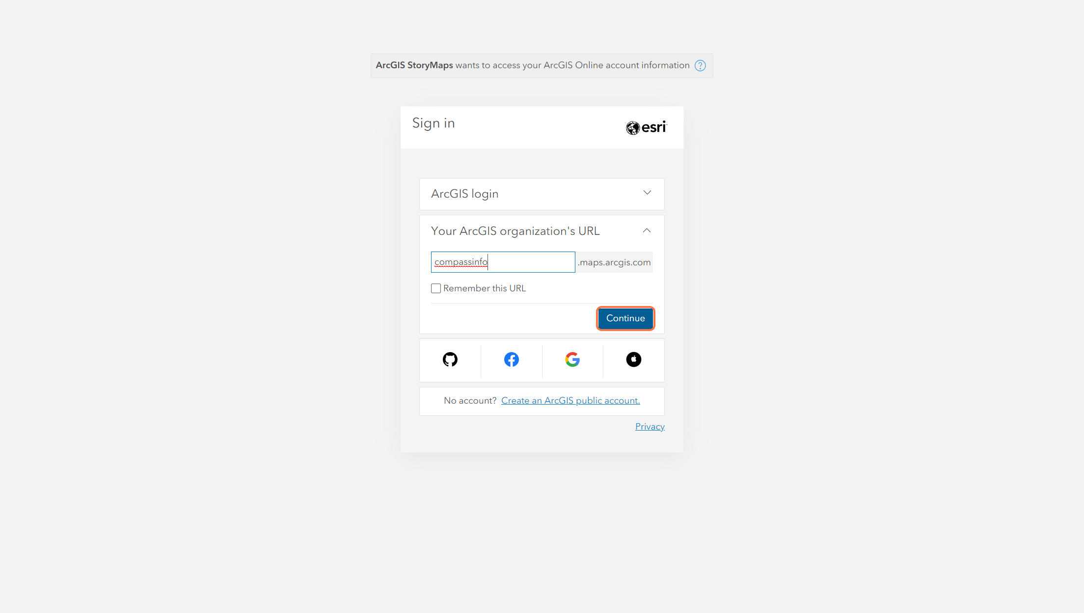

5 - Click on Compass Informatics

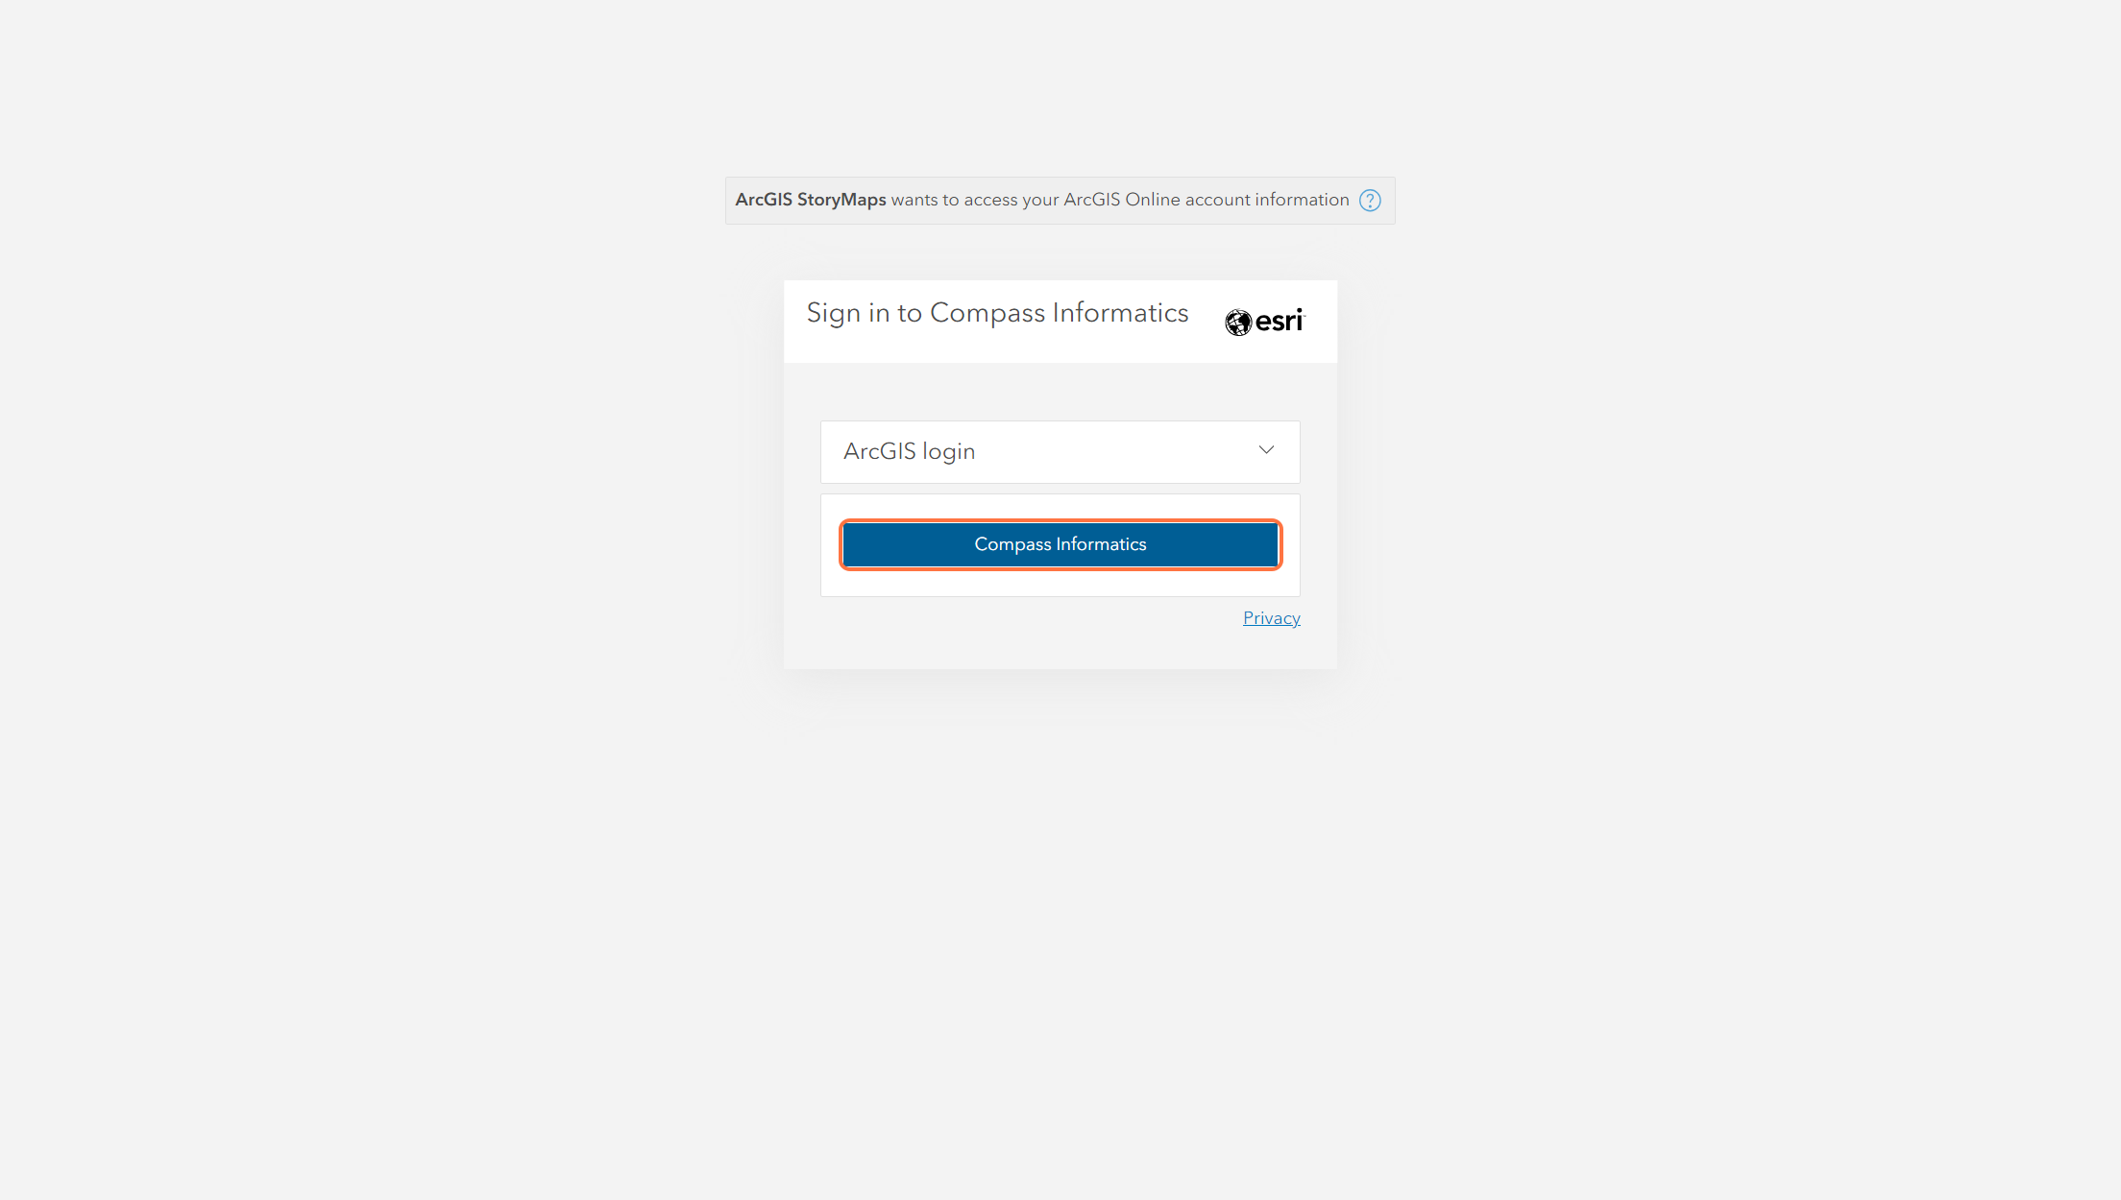

6 - Sign in with your Office 365 account

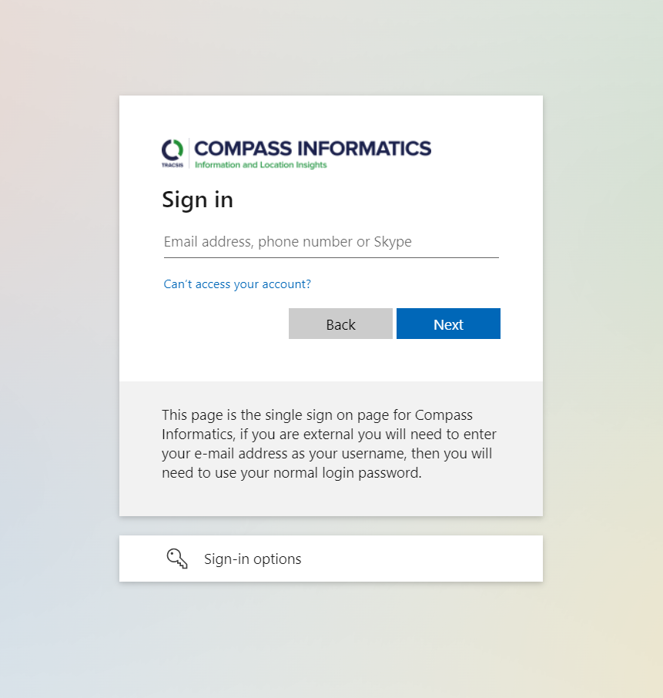

7- You will now see all your previously created stories

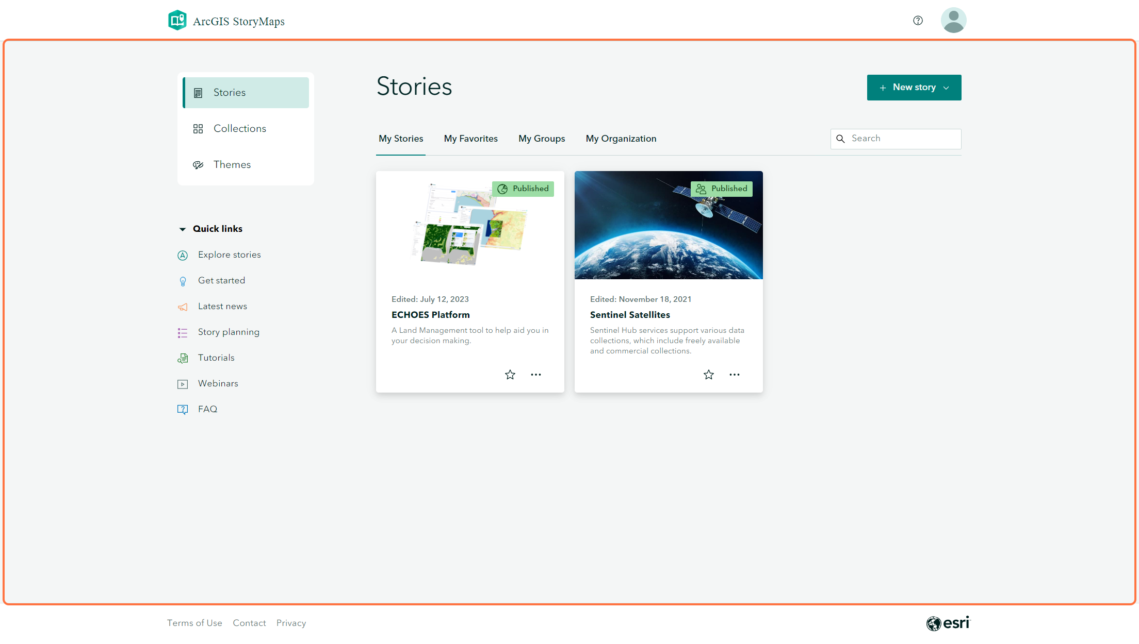

8 - Click on New story

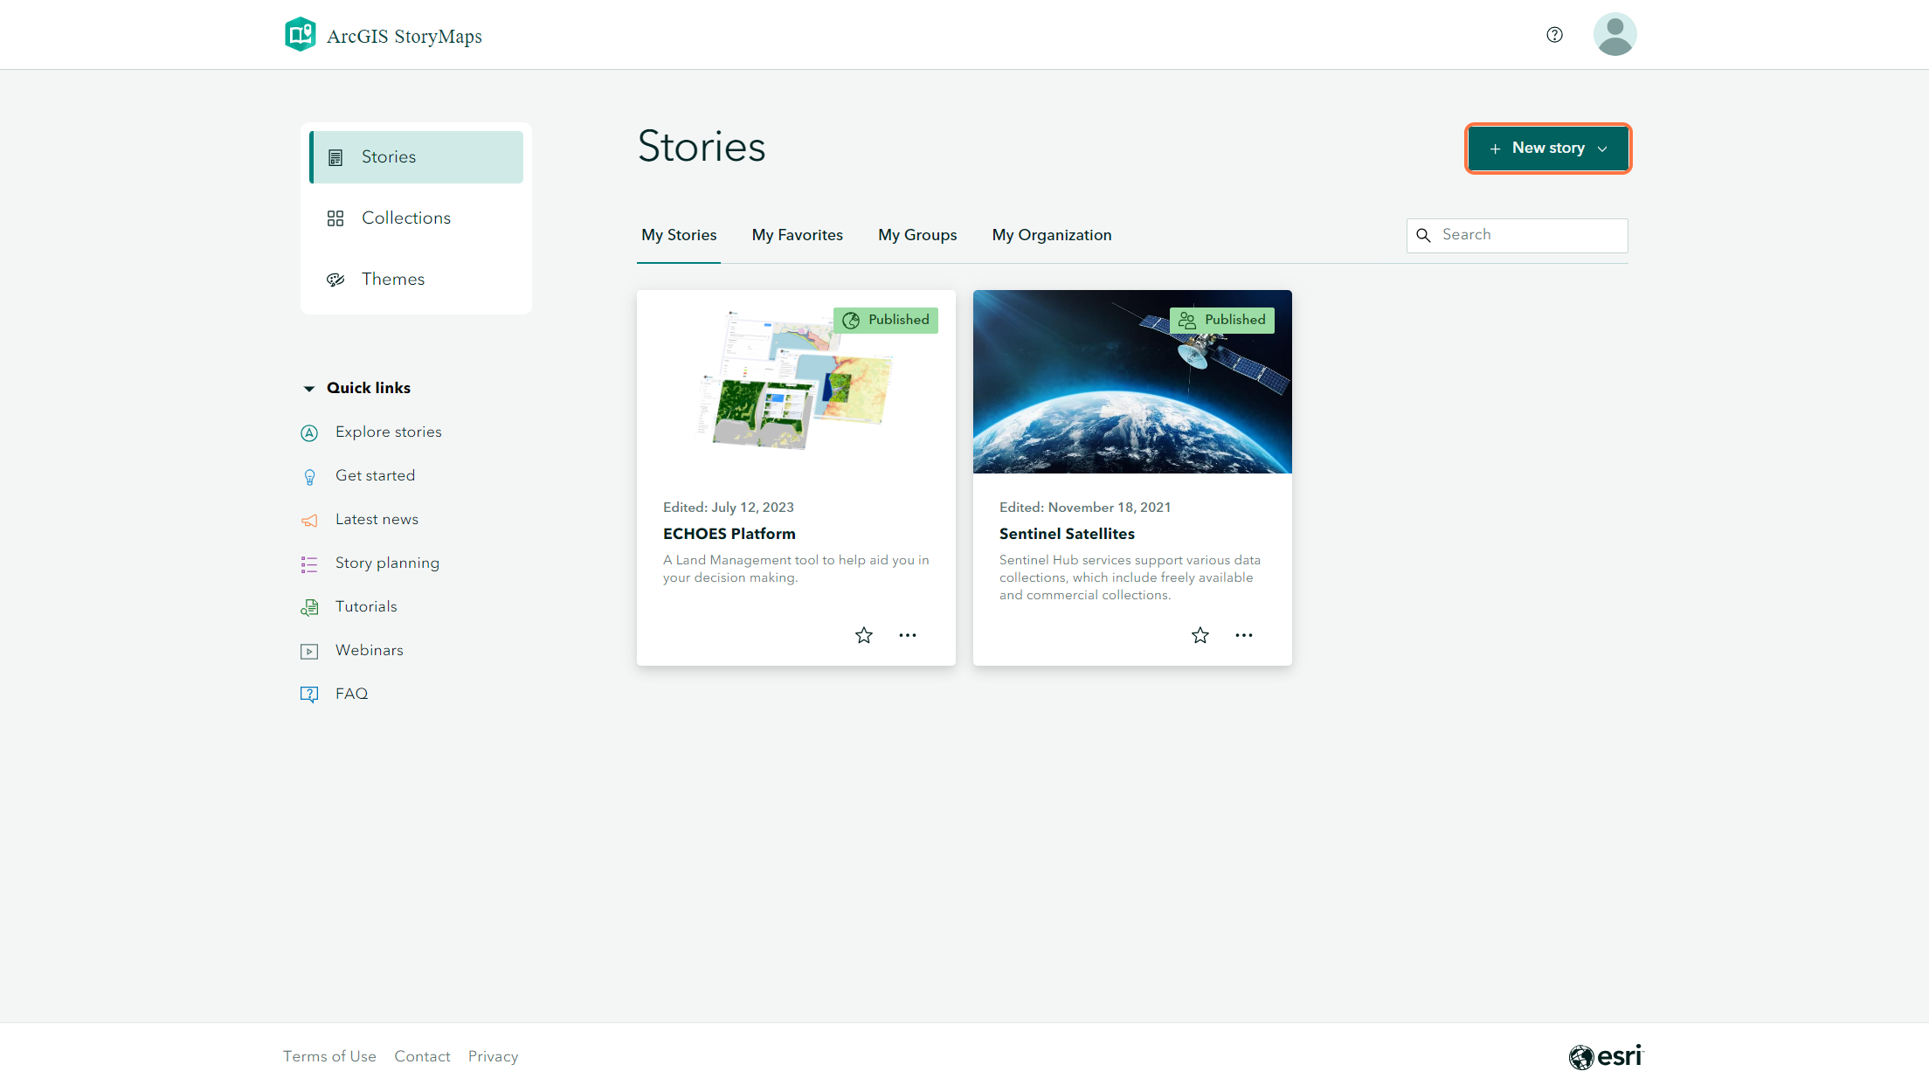

9- Click on Start from scratch

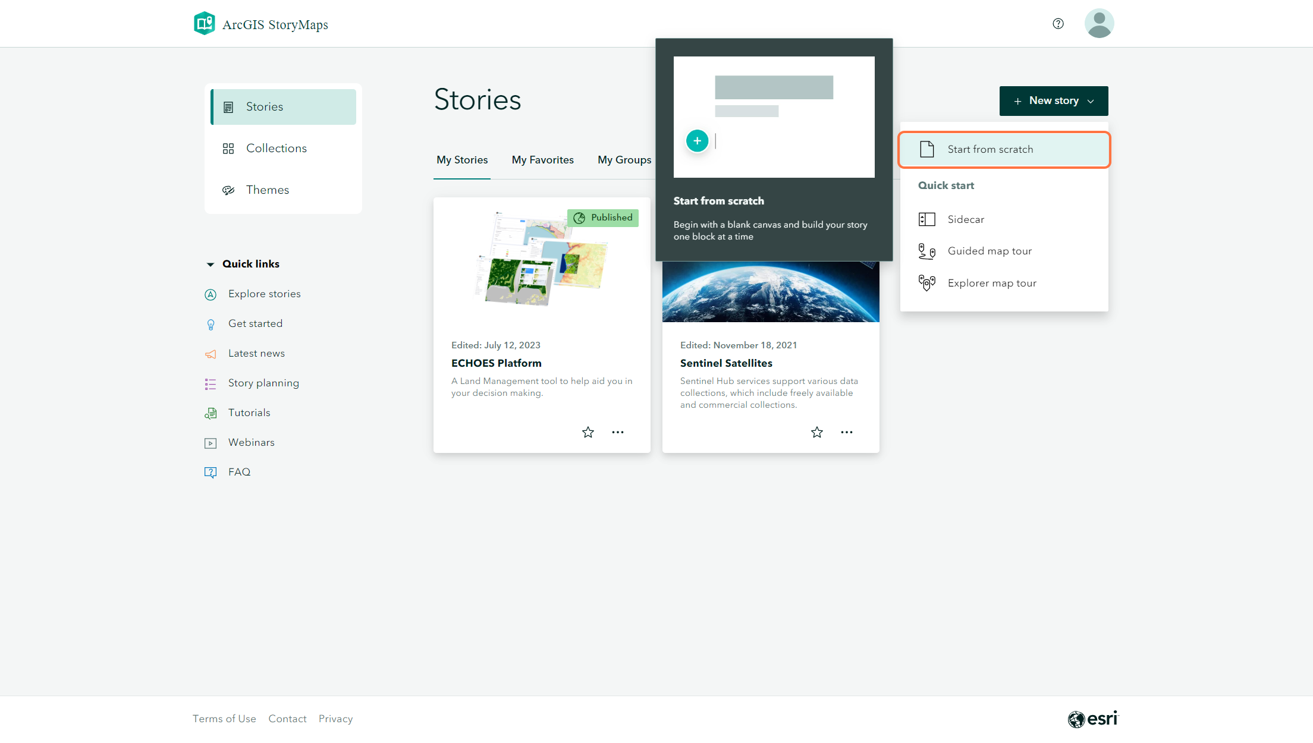

10 - Your blank story will now be visible. Giving the story a Title will name the document in the upper left-hand corner, currently 'Untitled story'

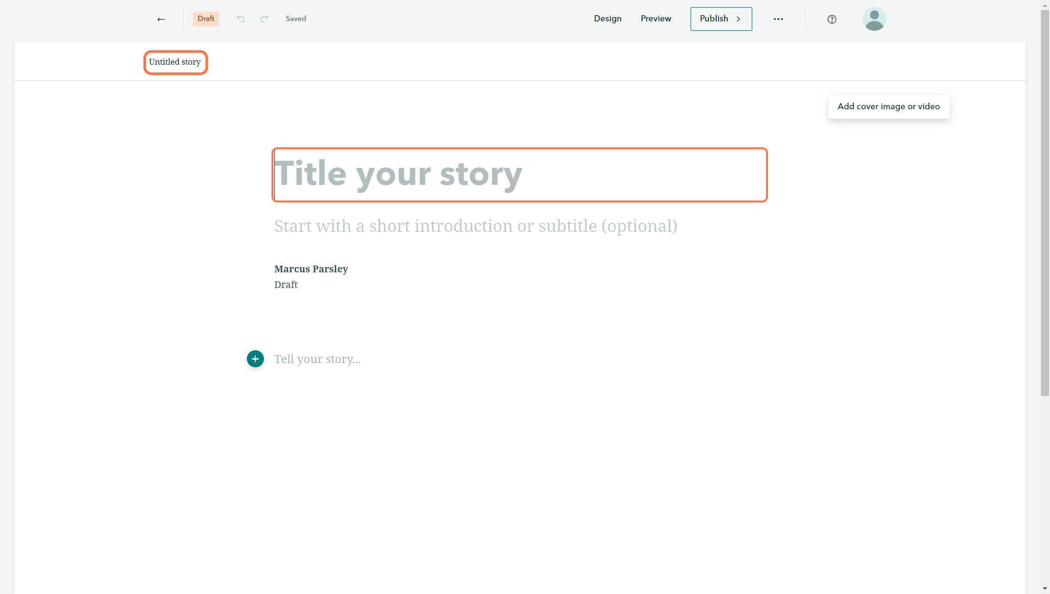

11 - Moving your mouse around the page you will see these '+' icons appear.

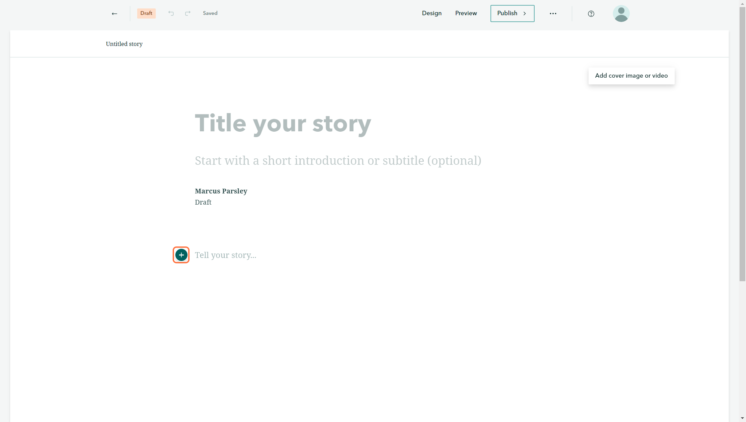

12 - Clicking on the '+' icon will present a list of all options you can add to the story.

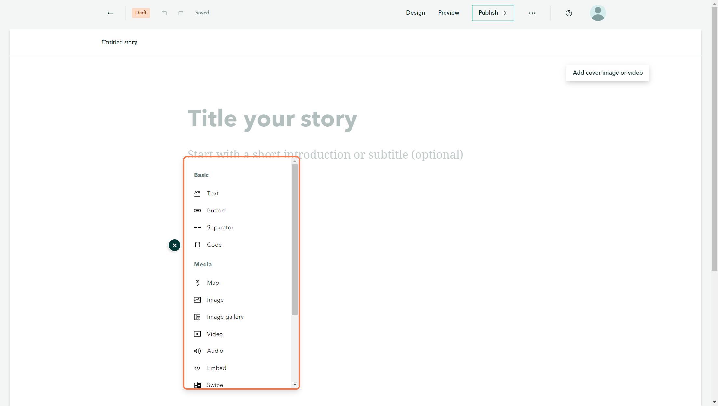

13 - To change some high-level designs you can click on the 'Design' button in the top right.

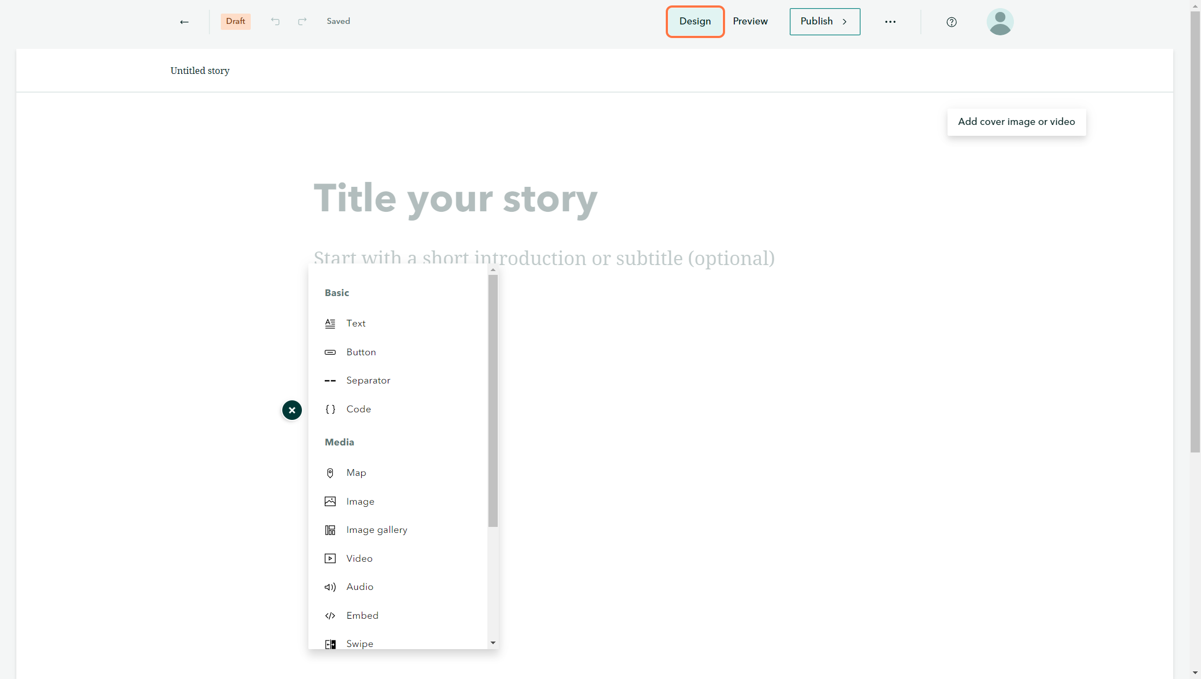

14 - Here you can choose the cover design, the Title and Hero image style

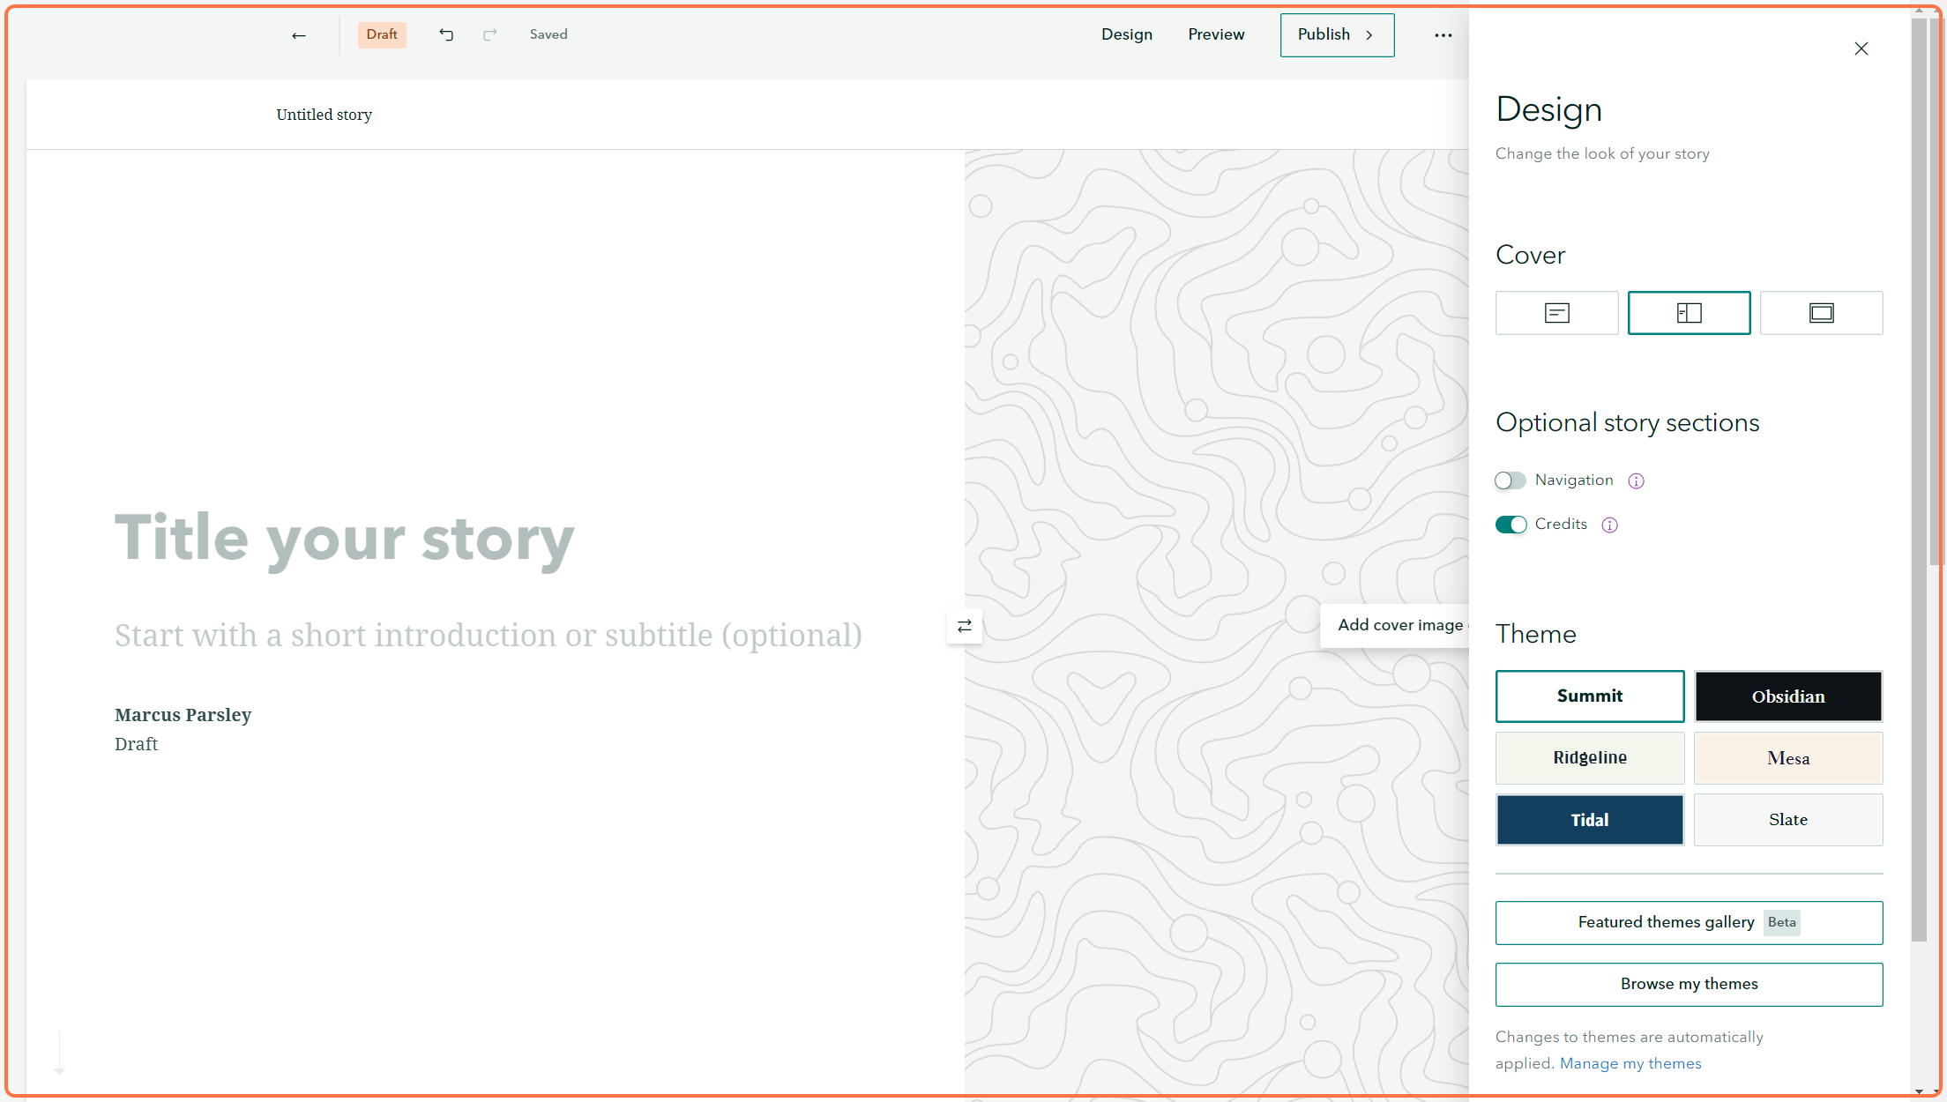

15 - Check the 'Navigation' toggle to create a sticky nav on your page of all the heading you create in your story.

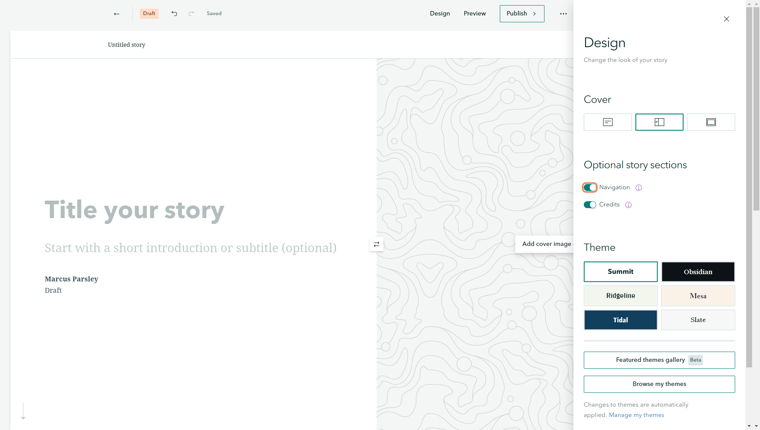

16 - You can choose a Theme for your story. This will change the colour, text style, separator styles etc.

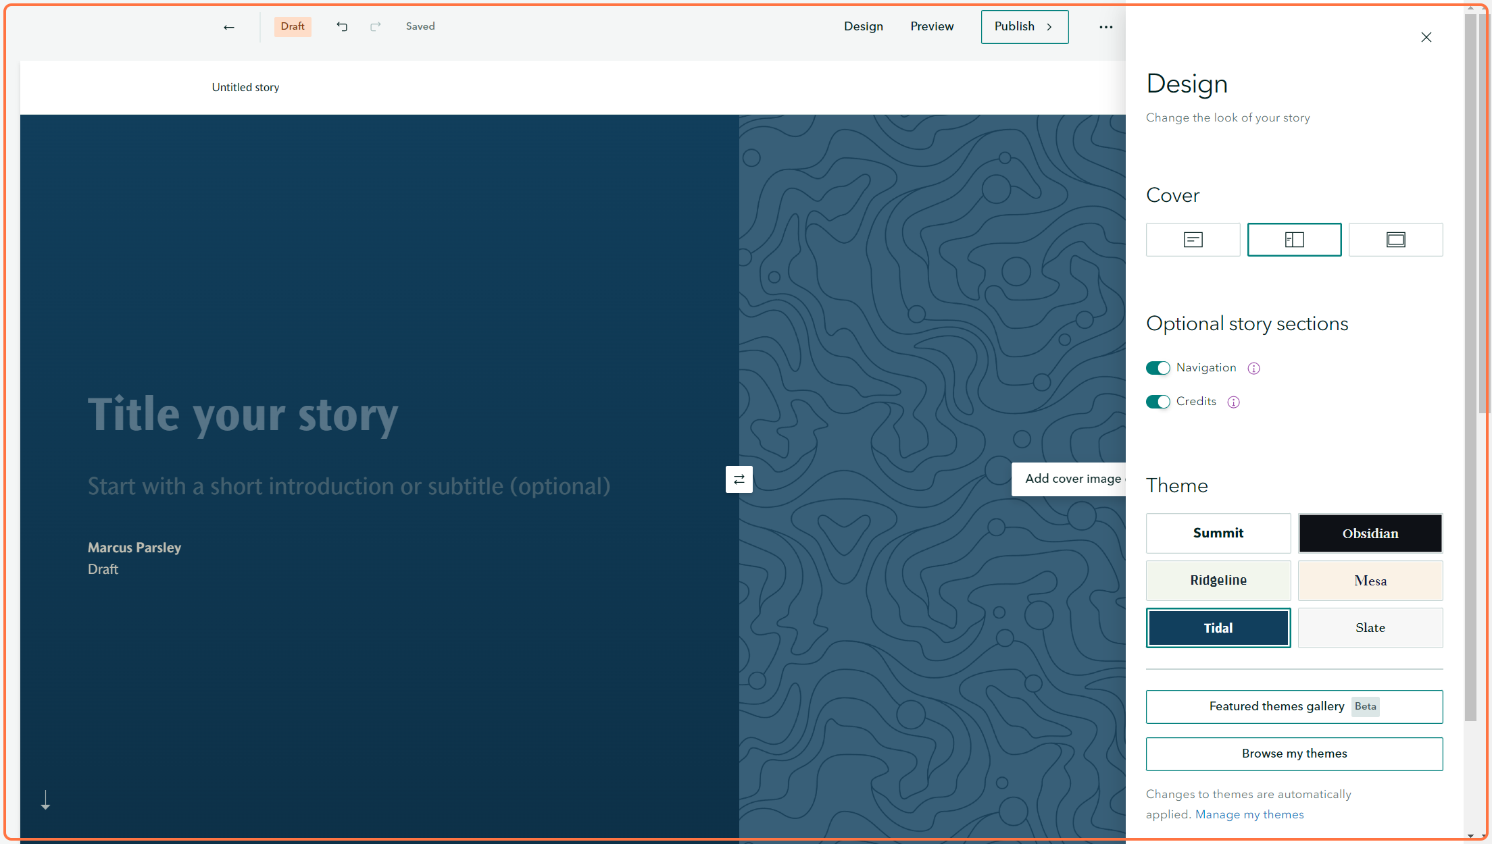

17 - Click on Upload logo to add a small icon/ logo to the top left of the Home screen, next to the Title name.

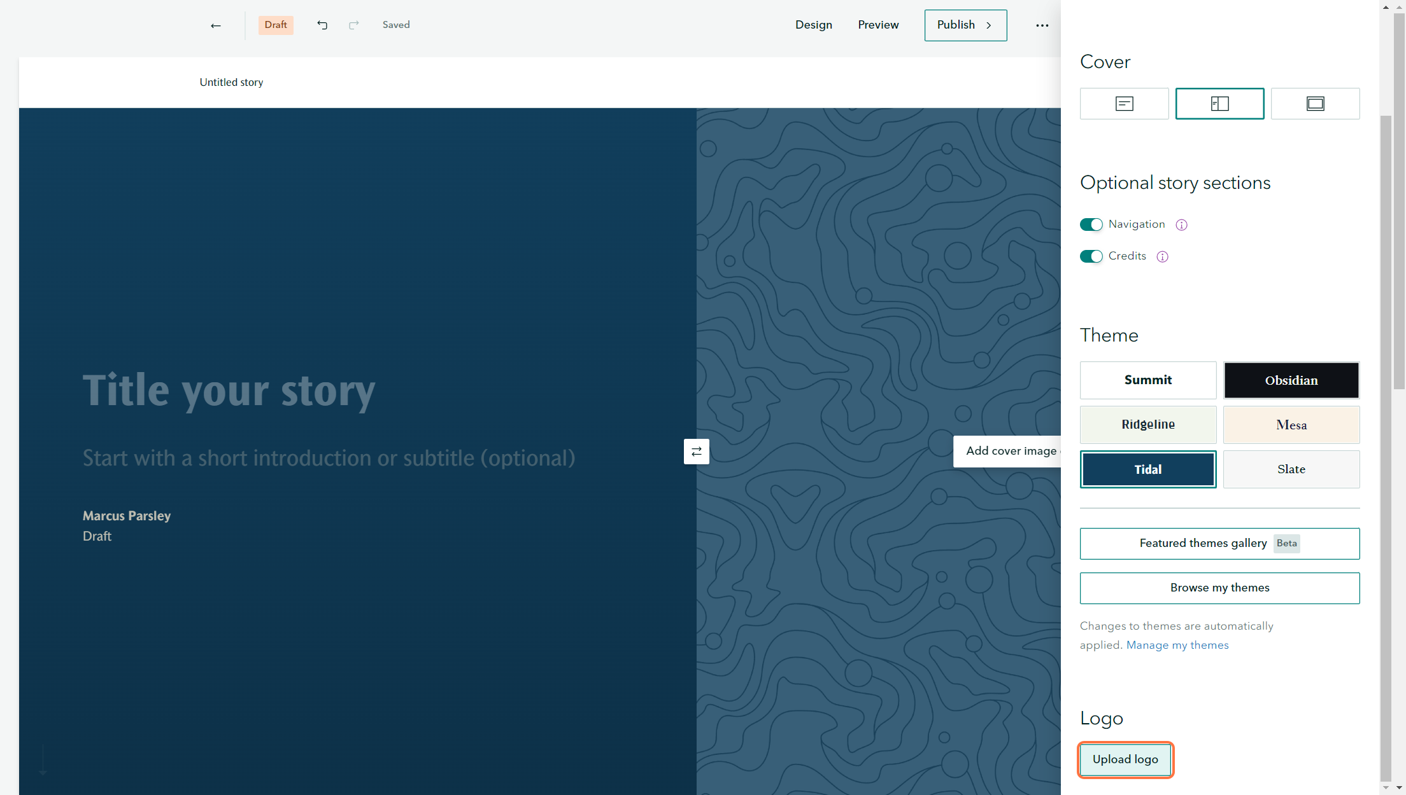

18 - Example of the logo uploaded next to the title.

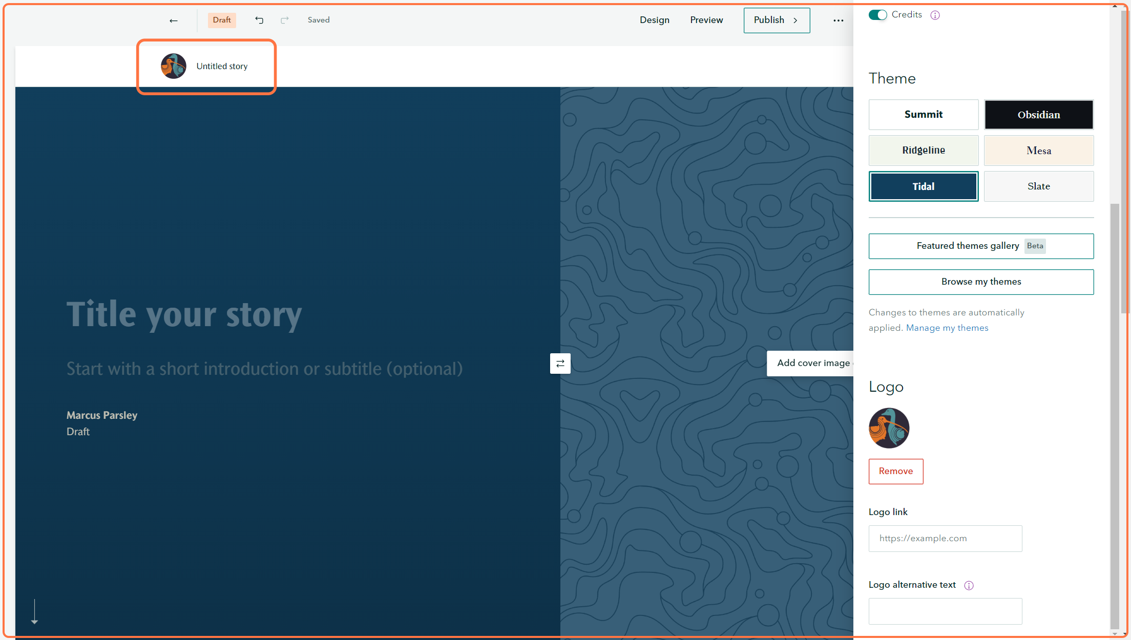

19 - Once you are happy with the story, you can click on the 'Publish'.

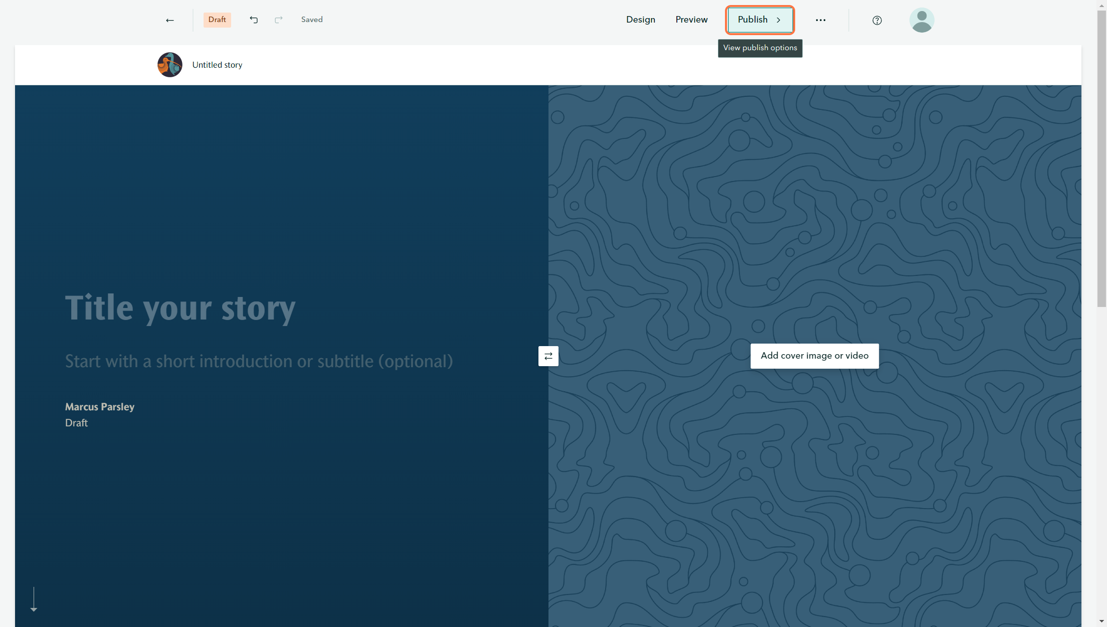

20 - Choose the Sharing level for when you publish the story.

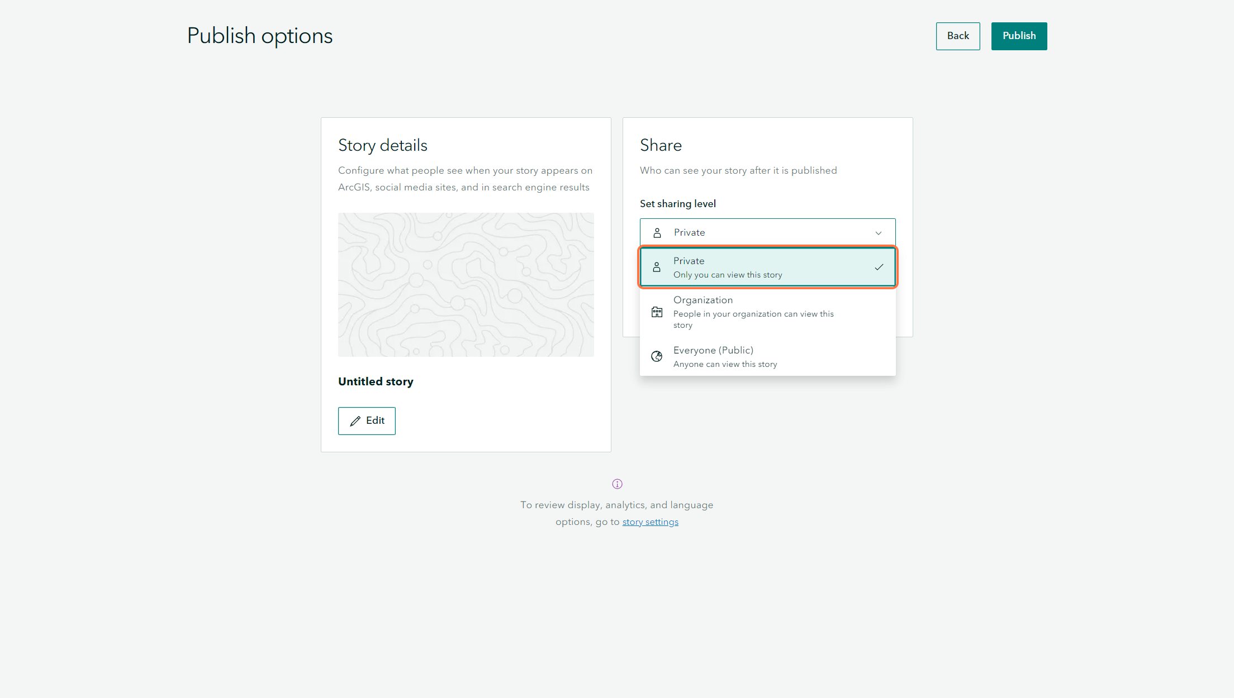

21 - To embed this story elsewhere, once the story is published you can go open the story and click on the Ellipses icon.

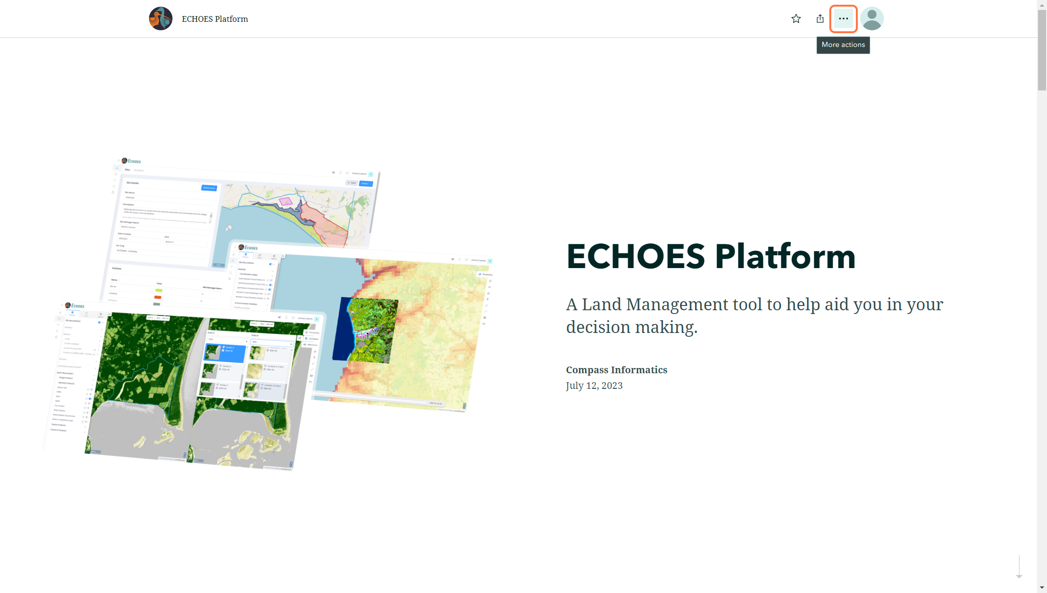

22 - Options will appear, click on the 'Embed this story' option.

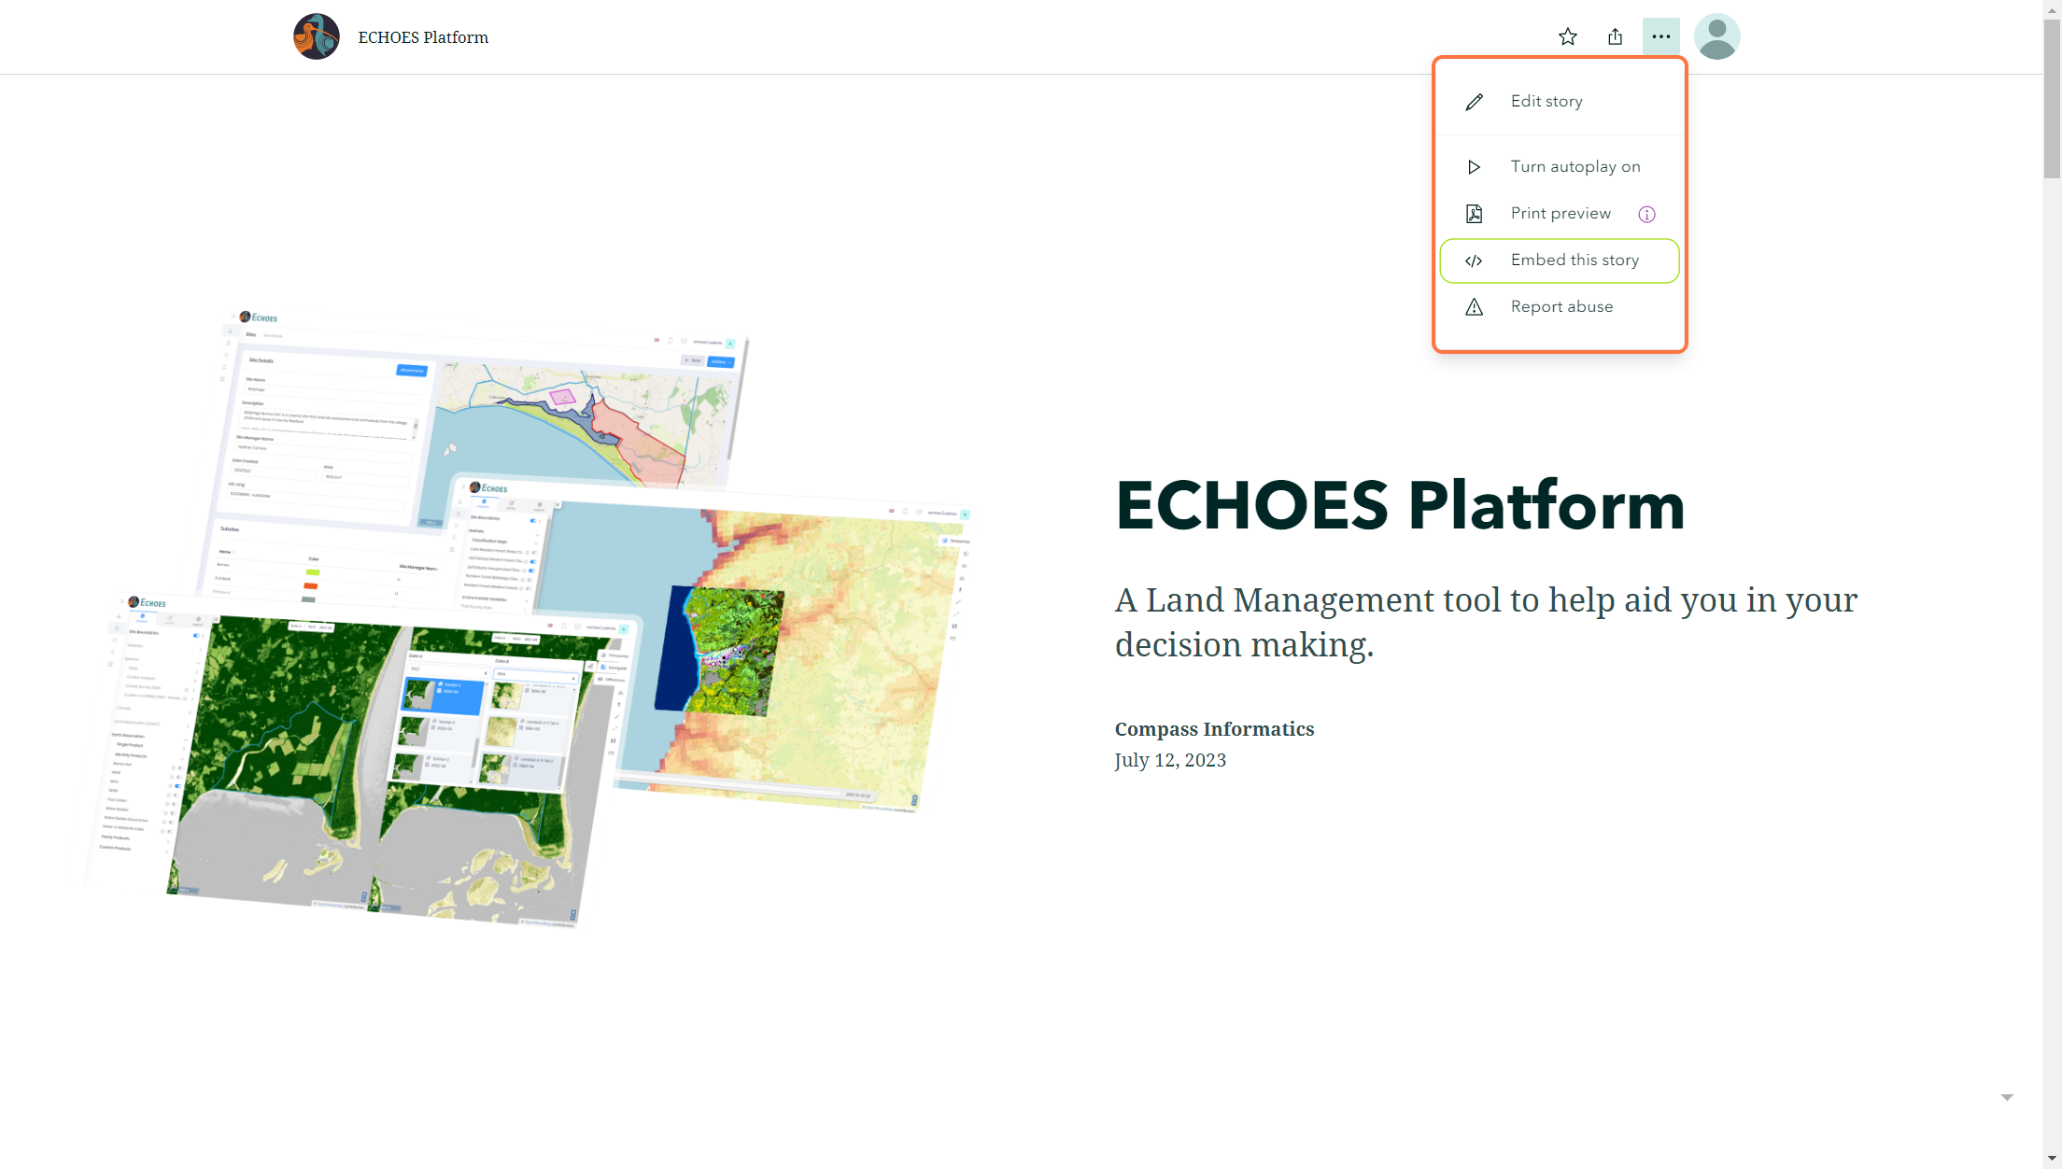

23 - Click on Copy, then you can embed this code elsewhere as an 'iframe'.

